MUHAMMAD NAIMATULLAH KHAN

COAL LAB 3

21K-4540

**QUESTION NO 1:**

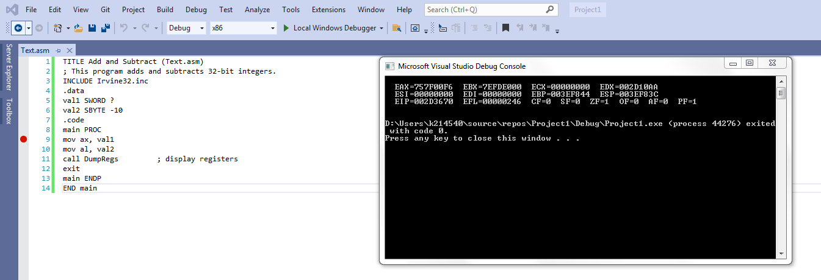

QUESTION NO 2:

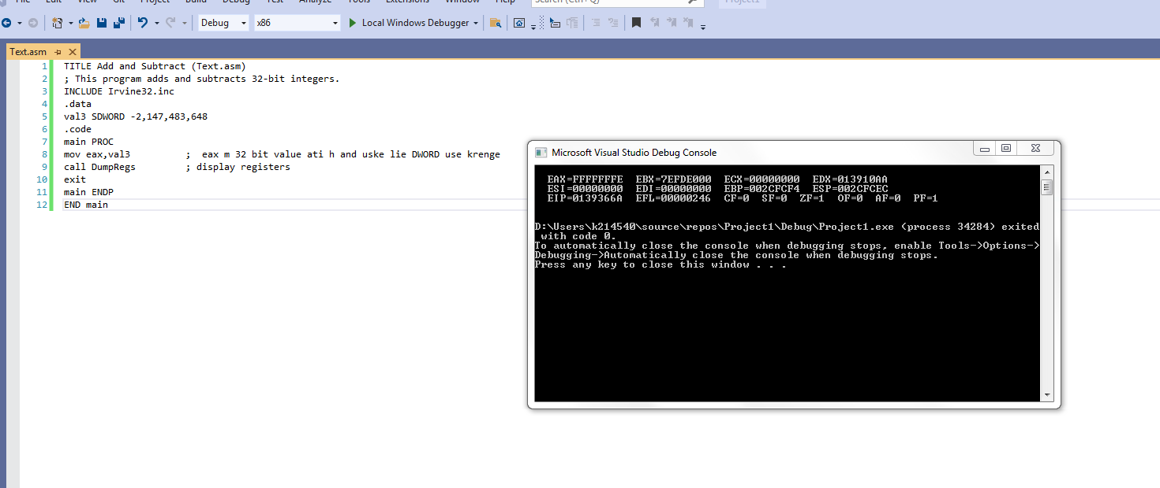

QUESTION NO 3:

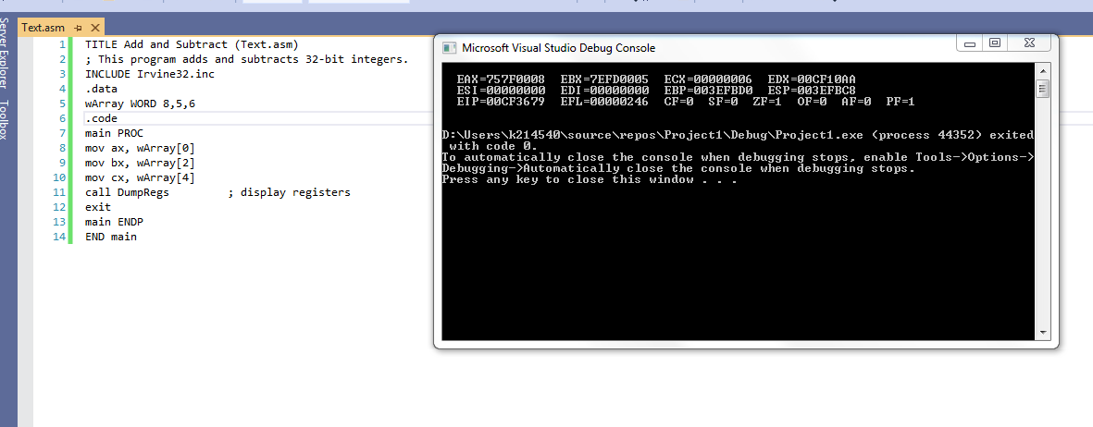

QUESTION NO 4:

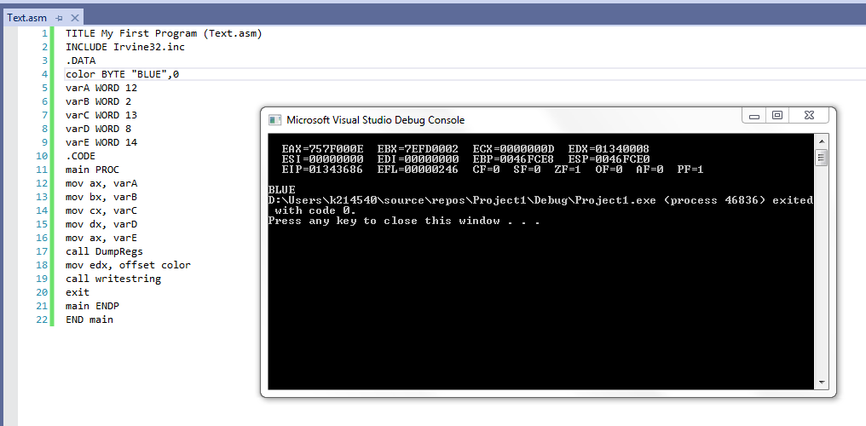

QUESTION NO 5:

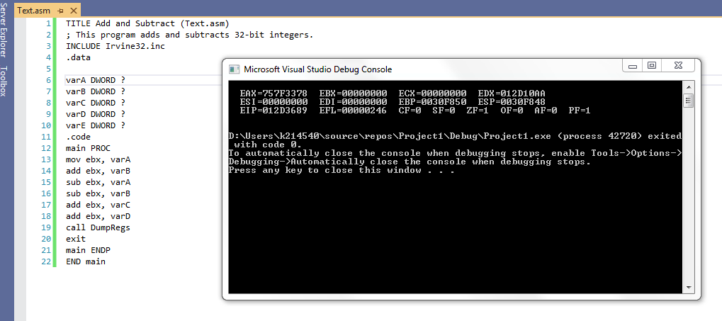

QUESTION NO 6:

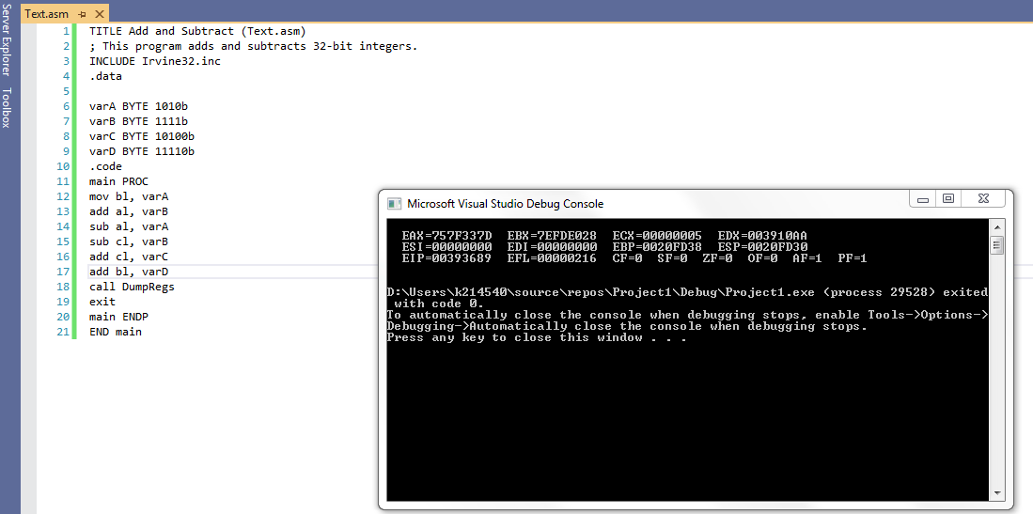

QUESTION NO 7:

